Project UML Diagram

university of asia pacific

dept. of cse



project title:

**“JARVIS Voice Assistant’’**

submitted by:

kaniz fatima (18201030)

mehedi hasan (18201042)

course code:

CSE 410

course title:

software development

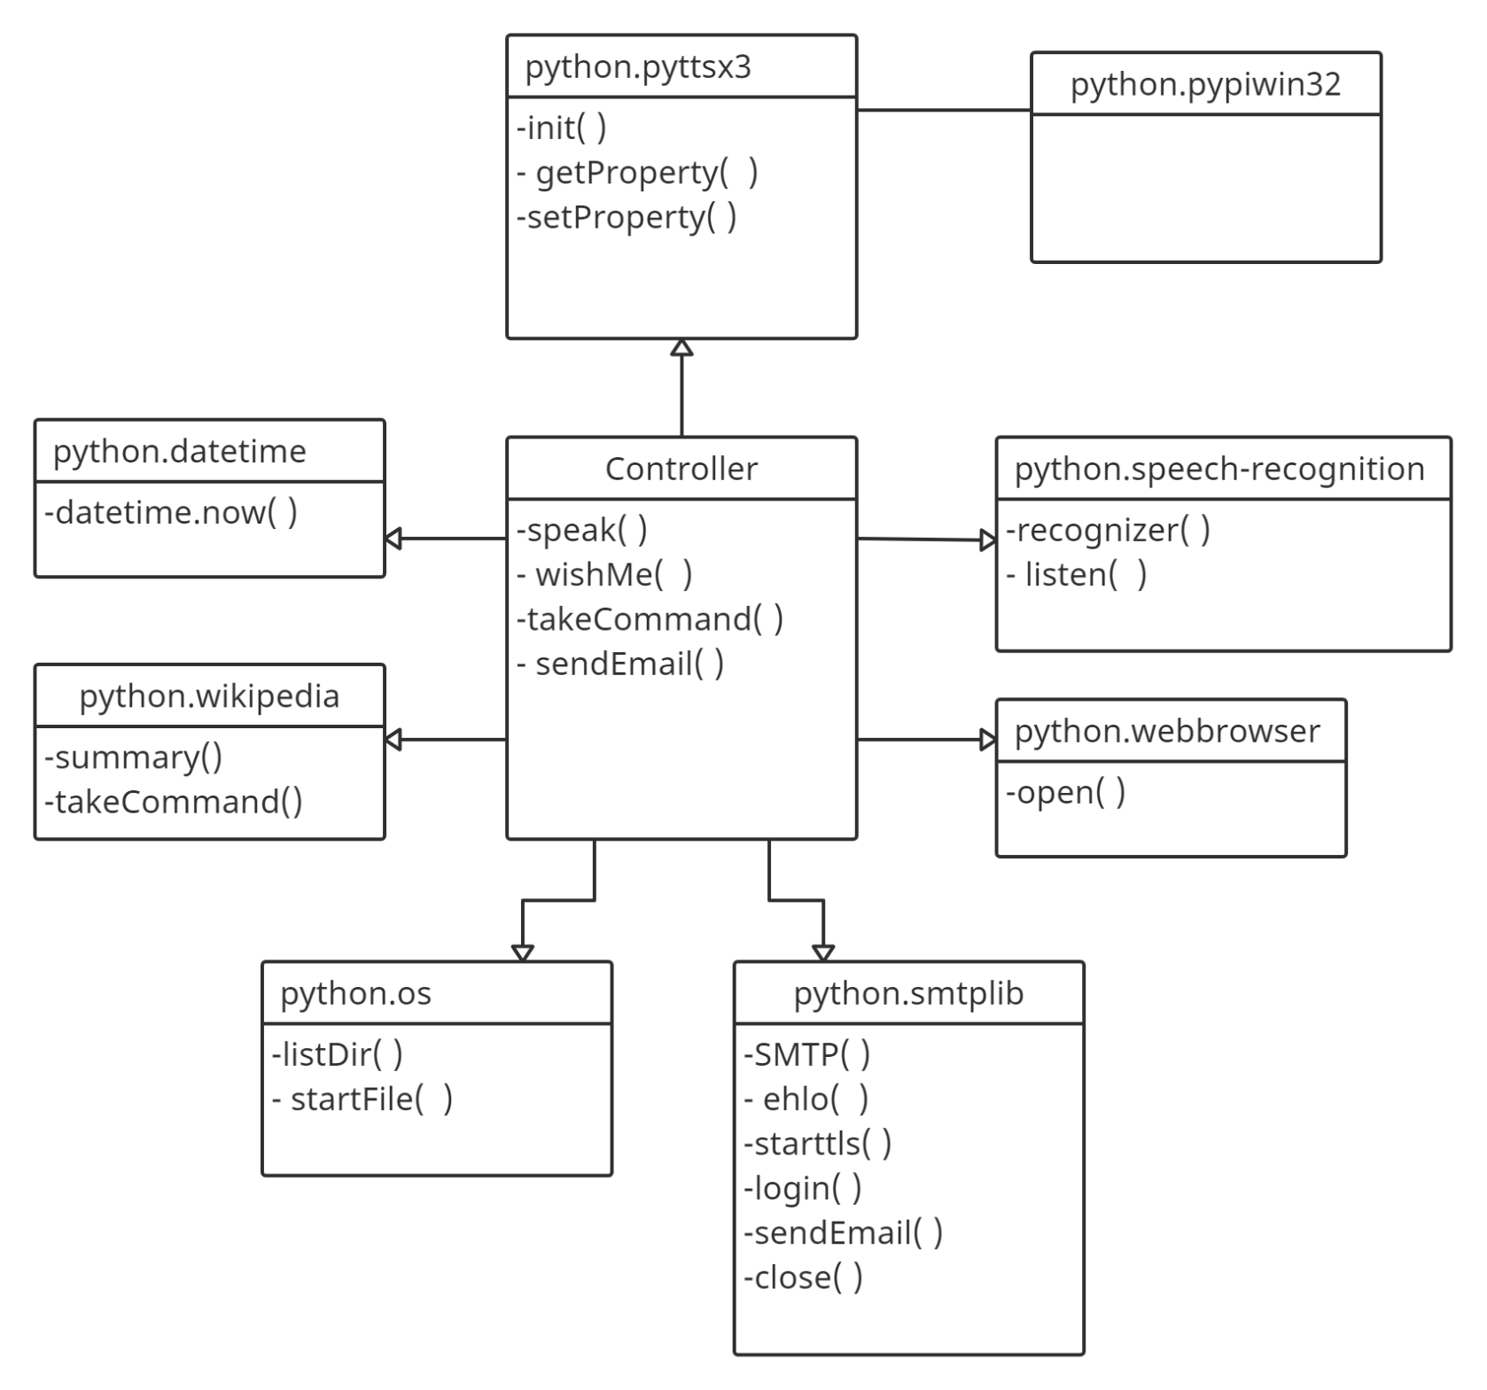

figure: UML Diagram of JARVIS Voice Assistant